WORDLE GAME

### PREPARED FOR

Dr. Hadeer A. Hosny

### PREPARED BY

Abdelaziz Karam Shaheen

Mustafa Kareem Nesim

Hane Hatem Ali Ali El-Basuony

Abdallah Fawzi Abd-Elsattar Salmah

### COURSE TITLE: OOP

### GROUP NUMBER: 1

Submission date: 09/06/2022

INTRODUCTION

The Wordle Game is a word guessing game with a simple 5x5 grid interface that has taken over the Internet as the most talked-about word guessing game, with a vast player base of over 2 million daily players all over the world. This is a game that is loved, shared a lot on social networks, and enjoyed by many players all over the world. A straightforward game with lines of words, similar to word games.

You will have some interesting experiences while playing the Wordle Game because you must find the correct word using only 5 letters and 5 guesses. By repeating the process over and over, you will gradually infer the correct word from previous attempts. You can play it for free.

The Wordle Game is extremely "attractive" to players because of its simple gameplay. In this crossword game, the tiles will change color in order to assist the player in locating the correct answer. The player has five chances to guess the correct answer to a five-letter word that is chosen at random.

When you have a few minutes to spare, playing Wordle Game is a great way to relax and clear your mind of worries. It may not increase your intelligence, but it's definitely fun and distraction-free. Who knows, you might be able to share your findings on Twitter in the near future.

### How to play the Wordle Game?

Guess the Wordle Game after 5 attempts, with each effort consisting of 5 letters. If you type a word and immediately see a letter become green “”, you have entered the proper word. It is possible that a letter will become yellow if it appears in the word to be guessed, but it will be in the incorrect location. Furthermore, if the letters are gray, it means that they were wrong guesses and should not be used again in the next word.

Each time you make a guess, the color of the crosswords will gradually change to indicate how close you are to getting the correct answer. Alternatively, you might simply try your luck and guess the proper word of the day in two or three turns, or even on the first turn.

PROJECT

OVERVIEW

# 

Our scope in this project is to create the game in java as all the source codes for this game are for browsers. The main page in the game is the Gamefield where you can input your words and play.

We have added some other features like leaderBoard and some animations for winning and losing.

That gave us the opportunity to learn and implement some of the topics we learned in this course (the object-oriented programming techniques, Gui front, and back end).

# 1. FEATURES

## **Simple UI**

* + The UI consists of three main pages

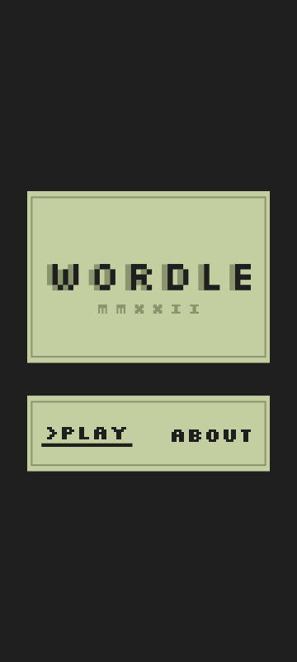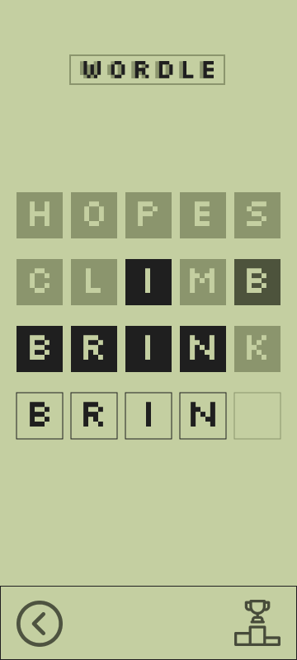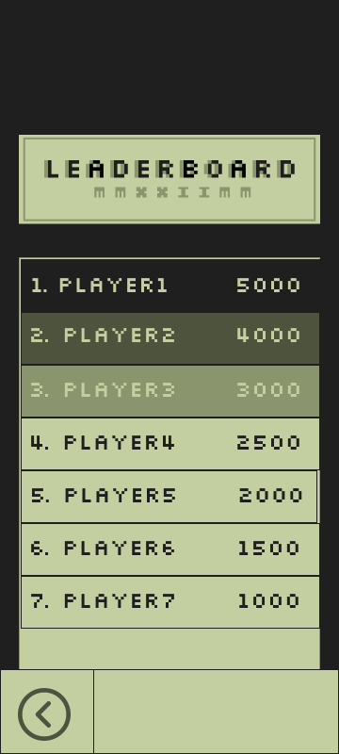

## **DATABASE CONNECTION**

* + The leaderBoard page connects to a simple database so we can add more users and each user has the opportunity to challenge other players
  + The user can enter his name after pressing the play button he gets a simple page to enter his name and no need to passwords.

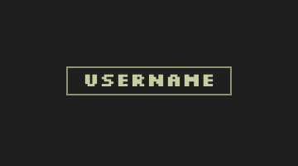

## **SIMPLE USER INTERACTIONS**

* + To enhance the user experience we have added some custom animations

And popup pages. And the main theme of the project is retro-based to give the user a more familiar look and feel.

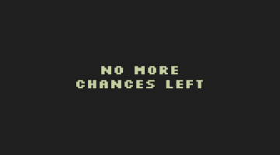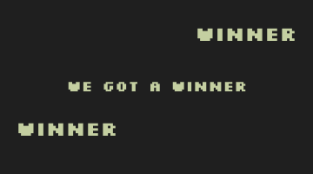

# 2. PROJECT MANAGEMENT

**Team Leader:** Abdelaziz Karam Shaheen

| **Milestone** | **Tasks** | **Team members involved** |
| --- | --- | --- |
| **1 - Design Concept** | | |
| 1.1 | Choosing project | 4 |
| 1.2 | Analysis and design stage, gather data and create system mockup using “Figma” | 1 |
| 1.3 | Design work plan (distribution of tasks) | 1 |
| **2 - Development** | | |
| 2.1 | Create GUI Front end using guideline from the mockup  Eash team member has to create on page | 4 |
| 2.2 | Developing the game algorithm | 4 |
| 2.3 | Create database | 2 |
| 2.4 | Developing the required algorithms to  send and receive required data | 2 |
| 2.5 | Integration with the final game | 4 |
| **3 - Testing** | | |
| 3.1 | Unit testing for each page | 2 |
| 3.2 | Integration testing for the final GUI “Front end” | 1 |
| 3.3 | Unit testing for the game algorithm | 2 |
| 3.4 | Integration testing for the final GUI “Back&Front end” | 1 |
| 3.5 | Testing the functionality of Database | 2 |
| 3.6 | Final integration Test for the Game | 1 |
| 3.4 | Finalise documentation | 1 |
| **4 - Deployment** | | |
| 4.1 | Resolving errors | 4 |
| 4.2 | Improving some of the functionality | 4 |
| **5 - Final Product** | | |

# 3. UML DIAGRAM

